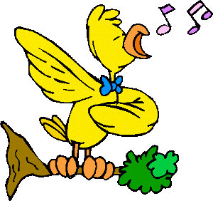








I was not
You were not
He wasn’t
She was not
It was not
We were not
You were not
They were not
Was I?
Were you?
Was he?
Was she?
Was it?
Were we?
Were you?
Were they?
I was
You were
He was
She was
It was
We were
You were
They were
To be
Past Simple
wasn’t

weren’t
SHORT ANSWERS: Yes, I/you/we/they were.
No, I/you/we/they weren’t.

SHORT ANSWERS: Yes, he/she/it was.
No, it/she/he wasn’t.

3rd person
singular!
A) Complete the sentences:

1. My father _______sick last week.
2. My sister and I _________ in the same school.
3. Her brother _________ (not) in the park on Monday.
4. ______ this pencil case mine? It sounds to me.
5. When I _______ in high school Mary _______my best friend.
6. _______your dog black and white? Yes, it ______
7. Peter and his girlfriend ________ (not) together at the disco yesterday night.
8. These dogs ___________ abandoned.
9. _________you shopping yesterday? No, I _____ (not). I ______ at the concert.
10. _________ they at the airport two days ago? No they _______ (not). They __________ on the ship.
11. The pirates ___________ on this island one hundred years ago.
12. __________ their parrot in the house when you _______ there? No, it ________ (not). It _______
in Olivia’s house.
B) Find the mistake:
1. My younger brother and I was at the party last night.
2. My parrot weren’t green and yellow.
3. My mother were sick last week.
4. Her daughter were a doctor.
5. Was their pencils blue?
6. This window weren’t open one hour ago.

C) Answer the questions:
1. Were you at home yesterday night?
_______________________________________.
2. Was your last the exam easy for you?
_______________________________________.
3. Was your pencil on the table ten minutes ago?
_______________________________________.
4. Were you and your parents at the park yesterday?
_______________________________________.
5. Was your aunt with you last Monday?
_______________________________________.
6. Were you and your friends at school last Friday?
_______________________________________.

