|  |  |
| --- | --- |
| **Score** | |
|  | 10 |

**SECOND PARTIAL TEST**

**Student’s Name:** __________________________________

**Classroom:** FIRST ______ **Date:** ________________ **Level: A2.2 (First)**

**Instructions:**

* Read the questions carefully before answering them.
* Don´t cheat please, be honest.

1. **LISTENING: Listen and check the best option to complete each question. (1.5 Marks)**
2. What is her name?
3. Ben.
4. Allison.
5. Juanita.
6. How long has she waited?
7. for a long time.
8. she just arrived.
9. for 10 minutes.
10. What has the girl done lately?
11. She has been to some countries.
12. She has gone to the library.
13. She has gone to the Great Waterfall.
14. Who has traveled a lot?
15. Boy.
16. Girl.
17. Both.
18. **VOCABULARY. Match with lines the idioms with their meanings. (1.5 Marks)**
19. To be in the same boat. **1**. to be a very exciting novel or book.
20. To hit the books. **2.** to postpone an invitation or plan.
21. To be a real page turner. **3.** to be in the same situation.
22. To take a rain check. **4.** to study hard.
23. **VOCABULARY. Unscramble and write the correct word under the picture, use the vocabulary given. (1.5 Marks)**

|  |  |  |  |
| --- | --- | --- | --- |
| **pmacngia** | **atendat** | **yevrsu** | **cerepi** |

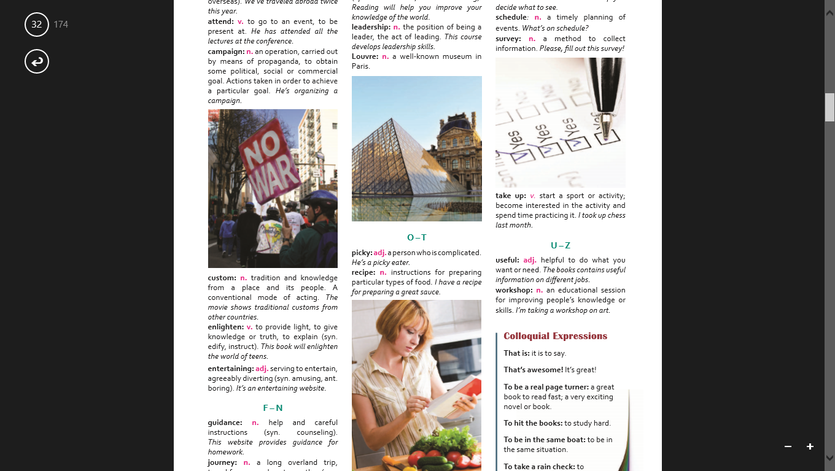

**___attend____ ____________ ____________ _____________**

1. **Complete the sentences with the PRESENT PERFECT TENSE POSITIVE. Use the verbs ( )in brackets. (1.25 Marks)**
2. I **__HAVE BEEN__** at the Shopping Center for a long time. **(be)**
3. Fred **____________________** a bus since 2009. **(buy)**
4. Miss. Smith **____________________** an accident. **(have)**
5. Rafael**____________________** a movie. **(find)**
6. Robert and Lore _**___________________** on the phone for 45 minutes. **(talk)**
7. Juanita **____________________** a medal. **(win)**
8. **Fill in the blanks with FOR or SINCE. (1.25 Marks)**
9. Charles hasn’t been here **_____SINCE____** nine o’clock.
10. Have you taken that bike **____________** a year?
11. Peter has been my friend **____________**we were eight.
12. We have been at Unidad Educativa “OSCAR EFRÉN REYES” **____________** 3 years.
13. I haven’t visited my hometown **____________** last month.
14. I have stayed with this dog **____________** 20 days.
15. **Complete these sentences using PRESENT PERFECT NEGATIVE. (1.25 Marks)**
16. I **have not been** at the shopping Center for a long time**. (be)**
17. Andrés ____________________ this jacket before. **(wear)**
18. You _______________________ sick since Tuesday. **(eat)**
19. They _______________________ to the Quito. **(travel)**
20. I _______________________ English for five years. **(know)**
21. He_______________________60 verbs. **(learn)**
22. **Use the following words and make QUESTIONS in PRESENT PERFECT TENSE. (1.5 Mark)**

We /sleep/ all night.

1. **______Have we slept all night?_____**

He/ write / a book.

1. **_______________________________**

She/ met / John.

1. **_______________________________**

Juanito and Pepito / buy / a house.

1. **_______________________________**

**BONUS: Complete the following verbs. (0.25 each one)**

|  |  |  |  |
| --- | --- | --- | --- |
|  | **PRESENT** | **PAST** | **MEANING** |
| **1** |  | **rode** |  |
| **2** | **sell** |  |  |
| **3** |  |  | **encontrarse con/ conocer a** |
| **4** |  | **thought** |  |
| **5** |  |  | **pelear** |

**GOOD LUCK!!!!**

**SECOND PARTIAL TEST**

|  |  |
| --- | --- |
| **Score** | |
|  | 10 |

**Student’s Name:** __________________________________

**Classroom:** FIRST ______ **Date:** ________________ **Level: A2.2 (First B)**

**Instructions:**

* Read the questions carefully before answering them.
* Don´t cheat please, be honest.

1. **LISTENING: Listen and check the best option to complete each question. (1.5 Marks)**
2. What is her name?
3. Ben.
4. Allison.
5. Juanita.
6. How long has she waited?
7. for a long time.
8. she just arrived.
9. for 10 minutes.
10. What has the girl done lately?
11. She has been to some countries.
12. She has gone to the library.
13. She has gone to the Great Waterfall.
14. Who has traveled a lot?
15. Boy.
16. Girl.
17. Both.
18. **VOCABULARY. Match with lines the idioms with their meanings. (1.5 Marks)**
19. To be a real page turner. **1**. to be in the same situation.
20. To take a rain check. **2.** to postpone an invitation or plan.
21. To be in the same boat. **3.**. to be a very exciting novel or book.
22. To hit the books **4.** to study hard.
23. **VOCABULARY. Unscramble and write the correct word under the picture, use the vocabulary given. (1.5 Marks)**

|  |  |  |  |
| --- | --- | --- | --- |
| **pmacngia** | **atendat** | **yevrsu** | **cerepi** |



**___attend____ ____________ ____________ _____________**

1. **Complete the sentences with the PRESENT PERFECT TENSE POSITIVE. Use the verbs ( )in brackets. (1.25 Marks)**
2. I **__HAVE BEEN__** at the Shopping Center for a long time. **(be)**
3. Fred **____________________** ten in his last test. **(get)**
4. Miss. Smith **____________________** an accident. **(have)**
5. Rafael**____________________** a movie. **(find)**
6. Robert and Lore _**___________________** the window. **(break)**
7. Juanita **____________________** a movie. **(see)**
8. **Fill in the blanks with FOR or SINCE. (1.25 Marks)**
9. Charles hasn’t been here **_____SINCE____** nine o’clock.
10. Peter has been my friend **____________**we were eight.
11. I haven’t visited my hometown **____________** last month.
12. We have been at Unidad Educativa “OSCAR EFRÉN REYES” **____________** 3 years.
13. I have stayed with this dog **____________** 20 days.
14. Have you taken that bike **____________** a year?
15. **Complete these sentences using PRESENT PERFECT NEGATIVE. (1.25 Marks)**
16. I **have not been** at the shopping Center for a long time**. (be)**
17. You _______________________ sick since Tuesday. **(eat)**
18. Andrés ____________________ this jacket before. **(wear)**
19. They _______________________ in the festival in Quito. **(sing)**
20. I _______________________ English for five years. **(know)**
21. He_______________________ bad, he had 01 in his test. **(feel)**
22. **Use the following words and make QUESTIONS in PRESENT PERFECT TENSE. (1.5 Mark)**

We /sleep/ all night.

1. **______Have we slept all night?_____**

He/ write / a book.

1. **_______________________________**

She/ know / 60 verbs.

1. **_______________________________**

Juanito and Pepito / teach / English.

1. **_______________________________**

**BONUS: Complete the following verbs. (0.25 each one)**

|  |  |  |  |
| --- | --- | --- | --- |
|  | **PRESENT** | **PAST** | **MEANING** |
| **1** |  |  | **ver** |
| **2** | **sell** |  |  |
| **3** |  |  | **encontrarse con/ conocer a** |
| **4** |  | **rode** |  |
| **5** |  |  | **vestir o llevar puesto** |

**GOOD LUCK!!!!**