**Name:** ___________________________  **Date:** _________________

**Level:________________**

**Countable nouns and Uncountable nouns**

**1. Write the words in the correct column.**

tomato apple soda banana rice milk apple juice tea vinegar mango sugar papaya

|  |  |
| --- | --- |
| **Countable nouns** | **Uncountable nouns** |
|  |  |
|  |  |
|  |  |
|  |  |
|  |  |
|  |  |

**2. Look at the pictures. Complete the questions. Use much or many.**

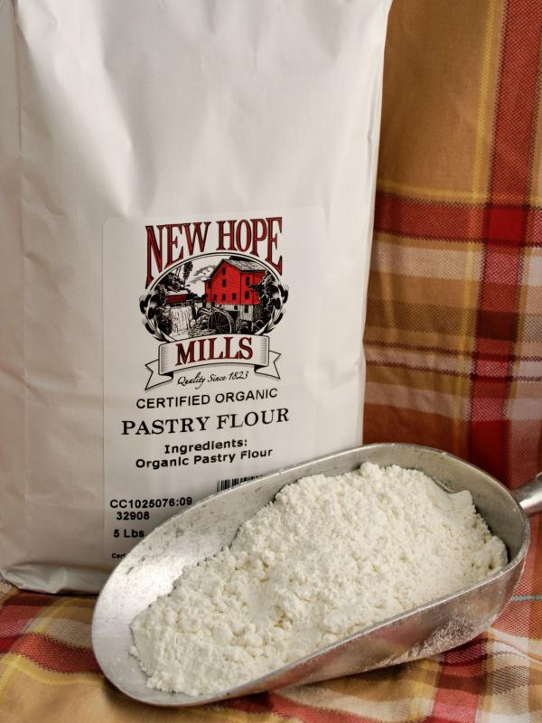 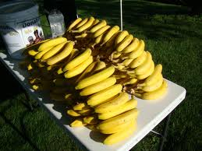 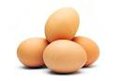 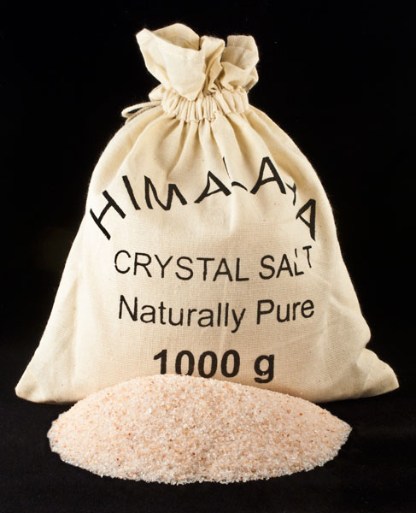

**1.** How ________  **2.** How _________ **3.** How __________ **4.** How _________ flour is there? bananas are there? eggs are there? salt is there?`

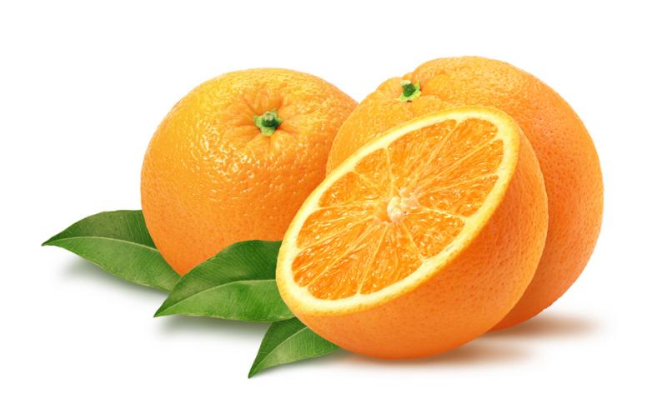 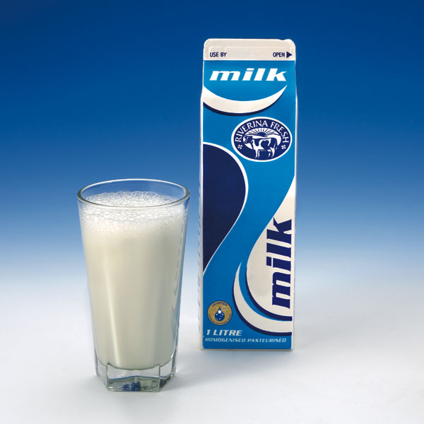 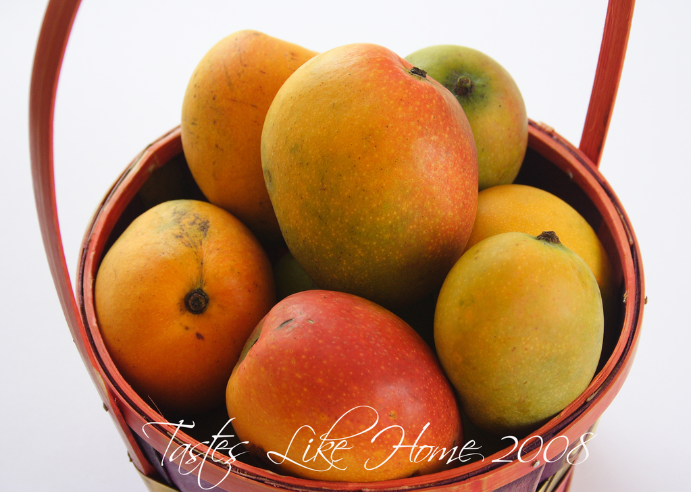 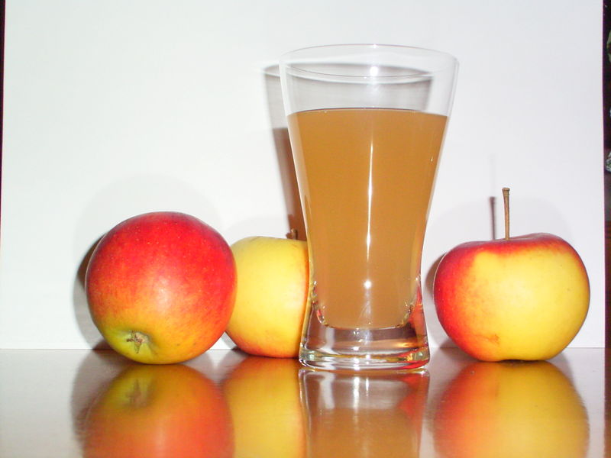 **5.** How ________ **6.** How ________ **7.** How _________  **8.** How ________ oranges are there? milk is there? mangoes are there? apple juice is there?

**3. Answer the questions from Exercise 2. Use the words in the box.**

a few a little a lot

**1.** There is a lot .

**2.** _____________________________.

**3.** There are a few .

**4.** _____________________________.

**5.** _____________________________.

**6.** _____________________________.

**7.** _____________________________.

**8.** _____________________________.