- WHAT ARE THESE THINGS? Write A / AN if necessary and the name of the thing. Some are countable and some are uncountable.

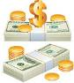  1 | 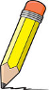  2 | 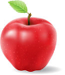  3 | 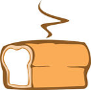  4 | 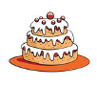  5 | 6  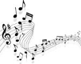
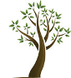  7 | 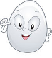  8 | 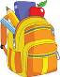  9 | 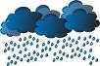  10 | 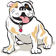  11 | 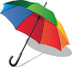  12

1. ____________________ 2. _____________________ 3. ______________________
4. ____________________ 5. _____________________ 6. ______________________
7. ____________________ 8. _____________________ 9. ______________________
10. ____________________ 11. _____________________ 12. _____________________

- Complete the sentences with A, AN or SOME:

Would you like _____________ coffee?
Would you like _____________ piece of chocolate?
Would you like _____________ water?
Would you like _____________ envelope for your letter?
Would you like _____________ glass of lemonade?
Would you like _____________ paper to write your note?

- What did they buy? Complete the sentences with A / AN or SOME:

Cris bought ____________ hat, ______________ shoes and ___________ magazine.

My mom bought ______________ toothpaste and _________________ food.

My brother bought _____________ postcards and ___________ stamps.

I bought ____________ interesting book!

4. And you? What did you buy last week? ________________________________________________________________________________________________________________________________________________

ANSWERS:

1. WHAT ARE THESE THINGS? Write A / AN if necessary and the name of the thing. Some are countable and some are uncountable.

- MONEY
- A PENCIL
- AN APPLE
- BREAD
- A CAKE
- MUSIC
- A TREE
- AN EGG
- A BACKPACK
- RAIN
- A DOG
- AN UMBRELLA

2. Complete the sentences with A, AN or SOME:

Would you like SOME coffee?
Would you like A piece of chocolate?
Would you like SOME water?
Would you like AN envelope for your letter?
Would you like A glass of lemonade?
Would you like SOME paper to write your note?

3. What did they buy? Complete the sentences with A / AN or SOME:

Cris bought A hat, SOME shoes and A magazine.

My mom bought SOME toothpaste and SOME food.

My brother bought SOME postcards and SOME stamps.

I bought AN interesting book!

