Name _________________________

No___ Class ___ Date ___/___/___
Cut the words and glue them under the right picture.

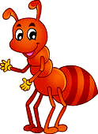
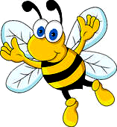
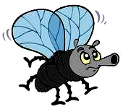



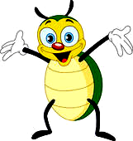
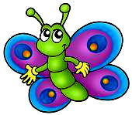
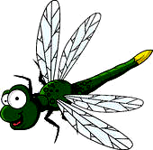
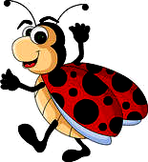
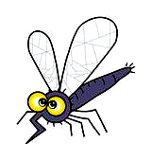
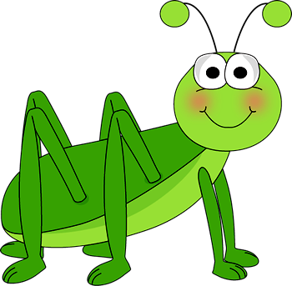
Beetle
Ant
Ladybug
Butterfly
Fly
Bee
Grasshopper
Mosquito
Dragonfly
_ _ _ _ _ _ _ _ _ _ _ _ _ _ _ _ _ _ _ _ _ _ _ _ _ _ _ _ _ _ _ _ _ _ _ _ _ _ _ _ _ _ _ _ _ _ _ _ _ _ _ _ _ _ _ _ _ _ _ _ _ _ _ _ _ _

