
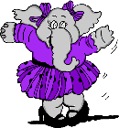

I can dance.
I can fly.
Positive
I can dance.
You can sing.
He can play volleyball.
She can ski.
A cat can climb trees.
We can swim.
They can drive.

Negative
I can’t dance.
You can’t sing.
He can’t play volleyball.
She can’t ski.
A cow can’t climb trees.
We can’t swim.
They can’t drive.
Question
Can I dance?
Can you sing?
Can he play volleyball?
Can she ski?
Can a cat climb trees?
Can we swim?
Can they drive?
?
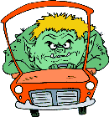

I can drive.

What can / can’t they do?
talk / swim / lift weights / skate / drive / play (2) / read / use / cook / walk / climb / ski / draw / ride / make




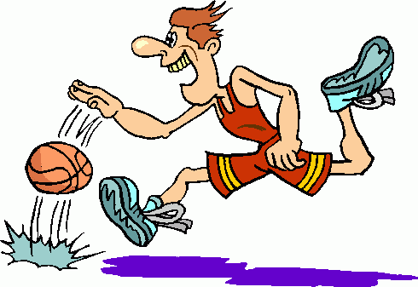

1-Judy ……………….…..a cake.

2-Adam ……..……………….

3-Albert ……………...………..

4-I……….….…..…basketball.




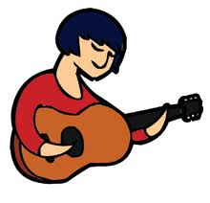

5-Simon …………….…………

6-She….……...…the guitar.

7-David ……………………….

8-You …………………………..


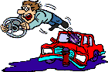
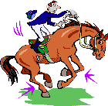


9-He ………….….……a horse.

10-I ……………………………….

11-Tom...……..…a computer.

12-Mike ……..………………..

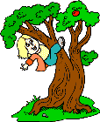

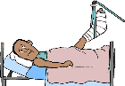

AGUU…

13-Jane ….……..………trees.

14-Alice ……………….…….

15-Alex …………………………

16-My brother is six months old. He ..…….……...

ASK & ANSWER

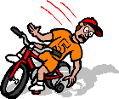



- Can she run?

– Yes, she can.

-………………………………….?

-………………………

-………………………………….?

-………………………

15-Alex …………………………

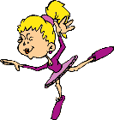

-………………………………….?

-………………………

-………………………………….?

-………………………

-………………………………….?

-………………………

15-Alex …………………………




