a wardrobe a lamp a window a bedside table
a picture a pillow a carpet a shelf a toybox
Label the picture:

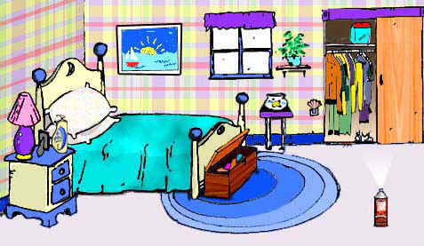

Fill in the sentences using the appropriate preposition of place:

in on under between next to in front of on

A picture is ________ the wall.
A bedside table is ________ the bed.
A lamp is ________ the bedside table.
A toybox is ________ the bed.
A window is ________ the picture and the shelf.
A carpet is ________ the toybox.
Clothes is ________ the wardrobe.


