**Final test - 4th grade**

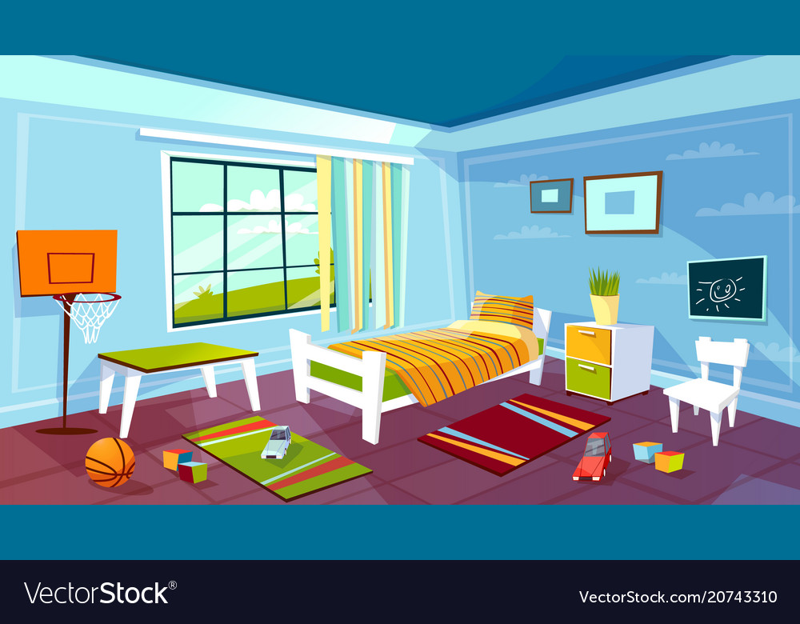

1. **Fill in the suitable preposition.**

**List of prepositions: *in, on, under, near, next to, in front of, behind, between.***

1. There is a bed ___________ the window.
2. There are toys ___________ the floor.
3. There is a table ____________ the backboard and the bed.
4. There is a plant ______________on the bedside table.
5. There are some pictures ___________the wall.
6. The bedside table is ____________ the bed.
7. **Answer the questions.**
8. Where is the basketball?

________________________________________________________________________________

1. Where are the pictures?

________________________________________________________________________________

1. Where is the plant?

________________________________________________________________________________

1. Where are the bricks?

________________________________________________________________________________

1. **What animals are these? Solve the anagrams.**

**OILN - __________ RAEBZ- _________**

**YHNOTP-__________ ECLRIODCO- ____________**

1. **Read and write the letter:**

**1** It can climb. It can’t fly. It’s got scales and teeth. It hasn’t got legs. 

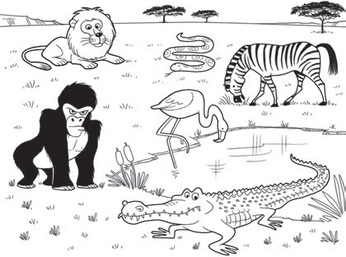

**a**

**b**

**d**

**c**

**e**

**f**



**2** It can run. It can’t fly. It’s got whiskers and claws. It hasn’t got scales.



**3** It can climb and run. It can’t fly. It’s got short legs and long arms. It hasn’t got a tail.

**4** It can fly. It can’t run. It’s got legs and feathers. It hasn’t got hair.

1. **Write at least 3 words for:**

Vegetables: ___________________________________

Fruit: ________________________________________

Dairy products: ________________________________

1. **Answer the questions:**

Do you like sausages? ________________________________________

Do you like bananas? _________________________________________

What´s your favourite food?____________________________________

Do you have salad for lunch?____________________________________

What do you have for breakfast?_________________________________

What do you have for dinner? ___________________________________