1 Warm – up activity: Try to guess who I am.
Hello. I ´m happy to be here with you, my friends. Let me intoroduce myself. My name´s......
I´m sorry. Try to guess my name. OK?
So, I lived in the end of (the)16th and begins of (the)17th century in England.
Elizabeth (the) I was the queen when I lived in England. I wrote many plays for her.
I wrotemany romantic sonnets, sad tragedies and funny comedies.
I also had my own theatre in London where only the men could be actors and play men´s and women ´s
roles. That sounds strange and funny, doesn´t it? ☺
I got married my love – Anne Hathaway when I was 18 years old. We had 3 nice children - (Susanna and twins Hamnet and Judith).
Believe me, I became one ot the most famous English writer and poet.
Do you know my name? Let me introduce myself. My name´s

2 VOCABULARY PUZZLE: Make pairs.
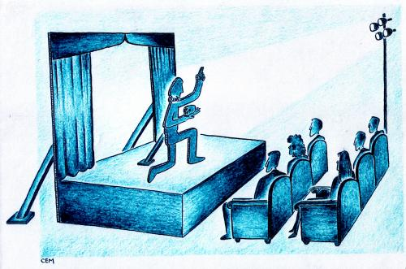
1 theatre a) básník

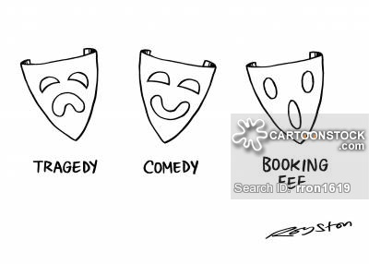
2 b) herec

3 c) milostný příběh

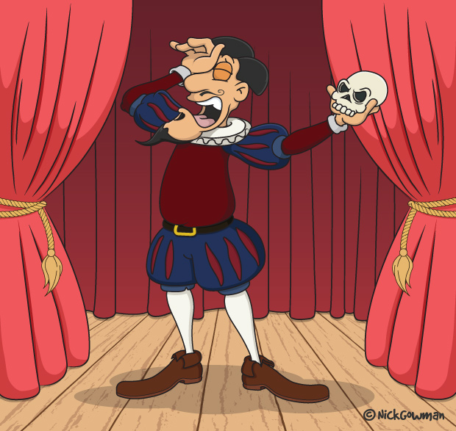
4 an actor d) tragédie

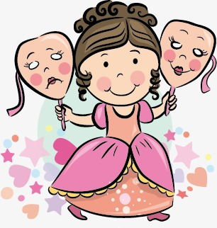
5 an actress e) komedie

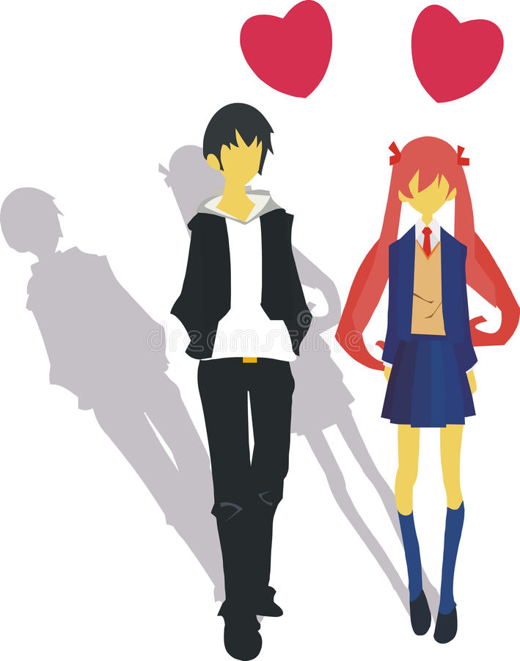
6 a lovestory f) herečka


7 a poet
g) divadlo
3 INFORMATION PUZZLE

William Shakespeare´s birthplace The Globe Theatre (1599)

William Shakespeare tragedy comedy

an English poet, playwright, writer Hamlet: “To be, or not to be? That is the quetion.“

The Taming of the Shrew - Zkrocení zlé ženy

Stratford-upon-Avon in London
